Ta mee ceau …… -I am wearing a … Cha nel mee ceau …. I am not wearing a .. S’mie lhiam ceau …… I like wearing a.
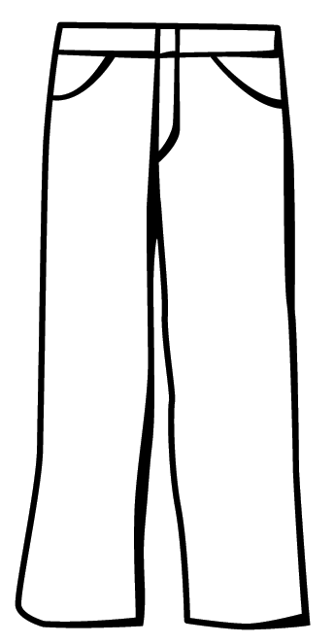 | 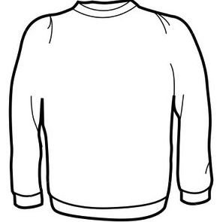 | 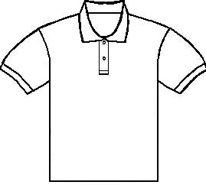
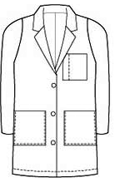 | 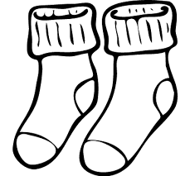 | 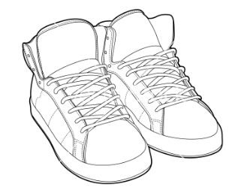

troosyn, gansee, lheiney-t(f), cooat , oashyryn(f), braaghyn(f), doo(ghoo), jiarg(yiarg), gorrym(ghorrym), bwee(wee), bane(vane)- white, glass(ghlass), dhone, gorrym-jiarg(ghorrym-jiarg),

