Class: Fuchsia Term: Spring 2026 Theme: People Who Help Us

Communication, Language and Literacy: Fiction: Stories From Other Cultures, Non-Fiction: Recounts
Talking and Listening – Participate in collaborative conversations. Develop understanding through speculating, hypothesizing, imagining and exploring ideas through role play. Justify answers, arguments and opinions.
Reading – Apply phonics skills and read by blending to decode unfamiliar words in a wide range of texts and genres. Listen to stories and poetry and discuss. Appreciate rhymes and poems and recite some by heart.
Writing – Punctuate sentences using capital letters, full stops, question and exclamation marks. Use conjunctions to extend sentences in fictional and non fictional writing. Use adjectives in descriptive writing. Compose a sentence orally before writing it. Know word classes - noun, subject and verb.

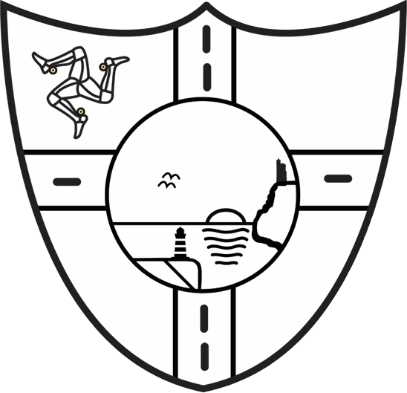

Mathematics:
Place Value
- Count, read and write numbers to 100 in numerals.
- Count to and across 100, both forwards and backwards.
- Count in multiples of 2s, 5s and 10s.
Addition and Subtraction to 20
Number bonds to 20, one more/one less.
Measures
- Measure and begin to record length and height.
- Compare, describe and solve practical problems for length/height.
Money
- Recognise & know the value of coins and notes.

Geography/Art/Music Focus:
- Begin to draw simple features observed in a familiar environment.
- Identify and describe where places are and compare the Isle of Man to somewhere far away, e.g. Thailand.
- Observational drawings of natural objects and manmade features.
- Painting. Make secondary colours (green, orange, purple) by mixing primaries and tints by adding white.
- Andy Warhol ‘Flowers’ (1970) -use as inspiration to paint own pictures.
- Music - Singing songs and chants. Composing. Understanding pitch and rhythm.

6R: Resilience and Resourcefulness
Jigsaw: Dreams and Goals. Healthy me.
- Identify and celebrate my success and achievements.
- Talk about how I learn best.
- Understand the difference between healthy and unhealthy.
- Know how to make healthy choices.

Physical Education: Dance/Gym/Games, (MSR)
- Complete actions, balances and shapes.
- Explore various movements.
- Make a shape and hold it.
- Express ideas and feelings through movement.
- Manx country dancing.
- Throwing and catching with bean bags and balls.

How you can help at home:
Read regularly and practise the learning of word walls. Practise reading and saying rhyming words. Predict what comes next in a story. Practise counting, reading, writing numbers to 100, both forwards and backwards.
Science: Investigate
Question, predict and set up an enquiry. Record and interpret data, e.g record the weather (rainfall), make an electrical circuit.
Physics ‘Light and Shadow’ - Know that:
- Light from a source is needed to see things.
- Darkness is the absence of light.
- Shadow is light blocked by an object.
- Opaque, translucent and transparent objects influence light travel.

